***Implementation of Maps:***

**Implementation using Hash Map:**

**code:**

package Maps;

//Map implementation using hash map

import java.util.*;

public class Map1{

@SuppressWarnings({ "removal", "rawtypes" })

public static void main(String args[]){

// Default initialization for map

Map<Integer, String> m1 = new HashMap<>();

Map<Integer, String> m2 = new HashMap<Integer, String>();

// Inserting the Elements or adding

m1.put(1, "Hi");

m1.put(2, "Hello");

m1.put(3, "Welcome");

System.out.println("\n On adding elements the output we get is \n\n"+m1);

m1.remove(3);

System.out.println("\n On removing elements the output we get is \n\n"+m1);

m1.put(3,"Namaste");

System.out.println("\n On changing elements the output we get is \n\n"+m1);

for (Map.Entry mapElement : m1.entrySet())

{

int key = (int)mapElement.getKey();

String val = (String)mapElement.getValue();

System.out.println("\nThe key and respective value is\n\n"+key + " --- " + val);

}

}

}

**Output:**

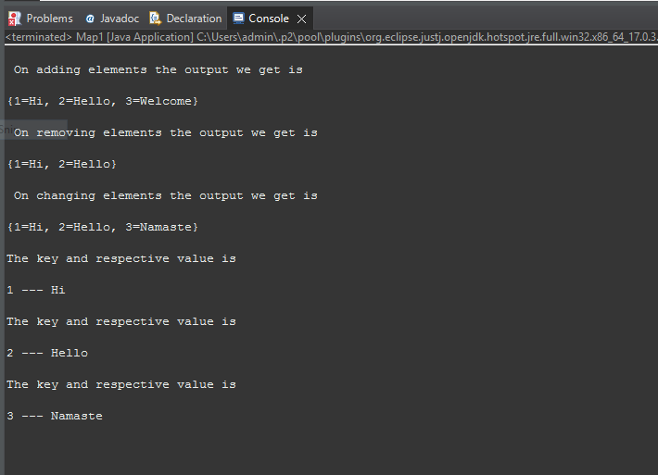

**Implementation using Tree Map and Linked Hash Map:**

**code:**

package Maps;

import java.util.*;

public class map2{

public static void main(String[] args){

// Implementation of map using linked hash map class

Map<String, Integer> m1 = new LinkedHashMap<>();

// Implementation of map using Tree Map class

Map<String, Integer> m2 = new TreeMap<>();

m1.put("One", 1);

m1.put("Two", 2);

m2.put("Three", 3);

m2.put("Four", 4);

for (Map.Entry<String, Integer> m : m1.entrySet())

System.out.println("\nThe output of linked hash map is\n"+m.getKey() + " " + m.getValue());

System.out.println("\nThe value of Tree Map before changing\n"+m2);

m2.replace("Three",8);

System.out.println("\nThe value of Tree Map after changing\n"+m2);

m2.remove("Three");

System.out.println("\nThe value of Tree Map after removing one value\n"+m2);

}}

**Output:**

